**LAB SESSION # 08**

**PREPARED BY: MUHAMMAD FARAZ ANSAR (SE-061)**

* **LAMP TEST:**

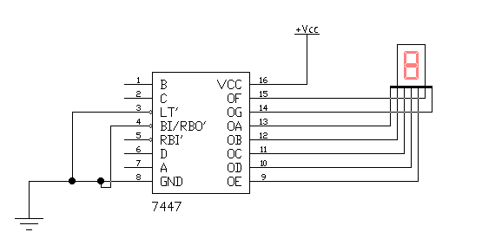

* **IMPLEMENTATION OF 74148-PRORITY ENCODER USING SEVEN SEGMENT DISPLAY:**

